DEPARTMENT OF COMPUTER SCIENCE & SOFTWARE ENGINEERING
COMSATS UNIVERSITY ISLAMABAD, VEHARI CAMPUS
PARALLEL PROGRAMMING MODELS
An In-Depth Comparative Study of Multi-Threading, OpenMP, MPI, and MapReduce: Core Architectures, Execution Pipelines, Code Illustrations, and Real-World Applications
Attribute | Details
Submitted By | Muhammad Ahmad Mujtaba
Registration No. | FA23-BSE-041
Academic Program | BS Software Engineering (BSSE) - Section A
Course Title | Parallel & Distributed Computing (CSC334)
Assignment | Assignment #02 (Parallel Programming Models)
Institution | COMSATS University Islamabad, Vehari Campus
Submission Date | Fall 2026 Semester

📌 Executive Summary & Core Objective
Modern high-performance software cannot rely on increasing CPU clock speeds. Instead, high throughput is achieved by orchestrating multiple computing cores and distributed clusters. This assignment explores the four dominant parallel programming models covered in our lectures: Multi-Threading (Shared Memory), OpenMP (Directive-Based Shared Memory), MPI (Distributed Memory Message Passing), and MapReduce (Data-Parallel Big Data). Each model is broken down with architectural diagrams, clear step-by-step mechanics, concrete code snippets, practical tradeoffs, and memorable real-world analogies.

No. | Section Heading | Core Topics Covered
1 | Introduction to Parallel Programming Models | Taxonomy, Abstraction layer, Shared vs Distributed spectrum, Analogy
2 | Multi-Threading Model (Thread-Based) | Address space, Shared vs Private memory, Mutexes, Pthreads code, Pitfalls
3 | Open Multi-Processing (OpenMP) | Fork-Join paradigm, Pragmas, Work sharing, Reduction clause, C++ code
4 | Message Passing Interface (MPI) | Distributed memory, SPMD model, Ranks, Send/Recv, Collective primitives, Code
5 | MapReduce Programming Model | Data locality, 3-phase pipeline (Map, Shuffle, Reduce), Word Count, Hadoop
6 | Comprehensive Comparison & Decision Guide | Grand 10-point comparison matrix, Decision flowchart, Hybrid MPI+OpenMP
7 | Conclusion & Key Takeaways | Summary of tradeoffs, engineering guidelines, and viva cheat sheet
8 | References | Primary literature, RFC standards, and academic course textbooks

Figure | Illustration Title | Primary Concept Illustrated
Figure 1 | Taxonomy of Parallel Programming Models | Categorization across Shared, Distributed, and Data-Parallel paradigms
Figure 2 | Single OS Process Address Space (Multi-Threading) | Shared Heap/Globals vs Private Thread Stacks, Registers, and PC
Figure 3 | OpenMP Fork-Join Parallel Execution Model | Sequential master thread, team fork, loop work-sharing, barrier join
Figure 4 | MPI Distributed Memory Cluster Architecture | Isolated physical nodes, private address spaces, high-speed interconnect
Figure 5 | MapReduce Distributed Data Processing Pipeline | 3-phase execution: Map phase, Shuffle & Sort grouping, Reduce phase
Figure 6 | Decision Guide: Choosing the Right Parallel Model | Flowchart mapping hardware, dataset scale, and developer constraints

1. Introduction to Parallel Programming Models
For decades, software engineers enjoyed automatic performance improvements simply by waiting for new hardware. As Gordon Moore predicted, transistor counts doubled roughly every two years, and CPU clock frequencies climbed steadily from megahertz to several gigahertz. However, around 2005, chip designers hit the 'Power Wall'—a thermodynamic limit where increasing clock speeds generated excessive heat and electrical leakage that could no longer be cooled economically. Dennard scaling collapsed.
To continue delivering performance gains, hardware manufacturers shifted strategy: instead of making a single core run faster, they placed multiple cores onto a single silicon chip (multi-core CPUs), built specialized chips with thousands of lightweight cores (GPUs), and clustered independent computers together over high-speed networks. Today, a modern computing environment can range from an 8-core smartphone to a 10,000-node supercomputing cluster.
However, hardware parallelism is completely useless unless software is explicitly written to exploit it. Standard sequential programs run on only one core at a time, leaving 80% to 99% of modern hardware idle. This is where Parallel Programming Models come into play.
1.1 What is a Parallel Programming Model?
A Parallel Programming Model is an abstraction layer that sits between the physical parallel hardware and the application software. It defines:
- Memory Organization: How processors view and access memory (Do they share one global address space, or does each processor possess a strictly isolated private memory?).
- Task Decomposition: How a large computational workload is divided into smaller concurrent sub-tasks.
- Inter-Worker Communication: How parallel workers exchange data (by reading/writing shared memory locations or by transmitting explicit network messages).
- Synchronization: How concurrent workers coordinate their timing, reach consensus, and avoid stepping on each other's work.
1.2 Taxonomy and Architectural Spectrum
Parallel programming models generally fall into three distinct architectural categories based on their target hardware and programming abstraction level:
- 1. Shared Memory Models: All execution workers run inside a single computer and read/write the same unified physical RAM. Examples include POSIX Threads (Pthreads), standard language threads, and OpenMP compiler directives.
- 2. Distributed Memory Models: Execution workers run across independent computer nodes connected via a network. Each worker possesses its own isolated RAM, and communication occurs strictly through explicit message passing. The gold standard is the Message Passing Interface (MPI).
- 3. High-Level Data-Parallel Models: Designed for massive big data analytics across hundreds or thousands of commodity servers. The framework hides low-level networking, memory buffers, and thread synchronization behind high-level transformations. The prime example is MapReduce (and its modern successor Apache Spark).
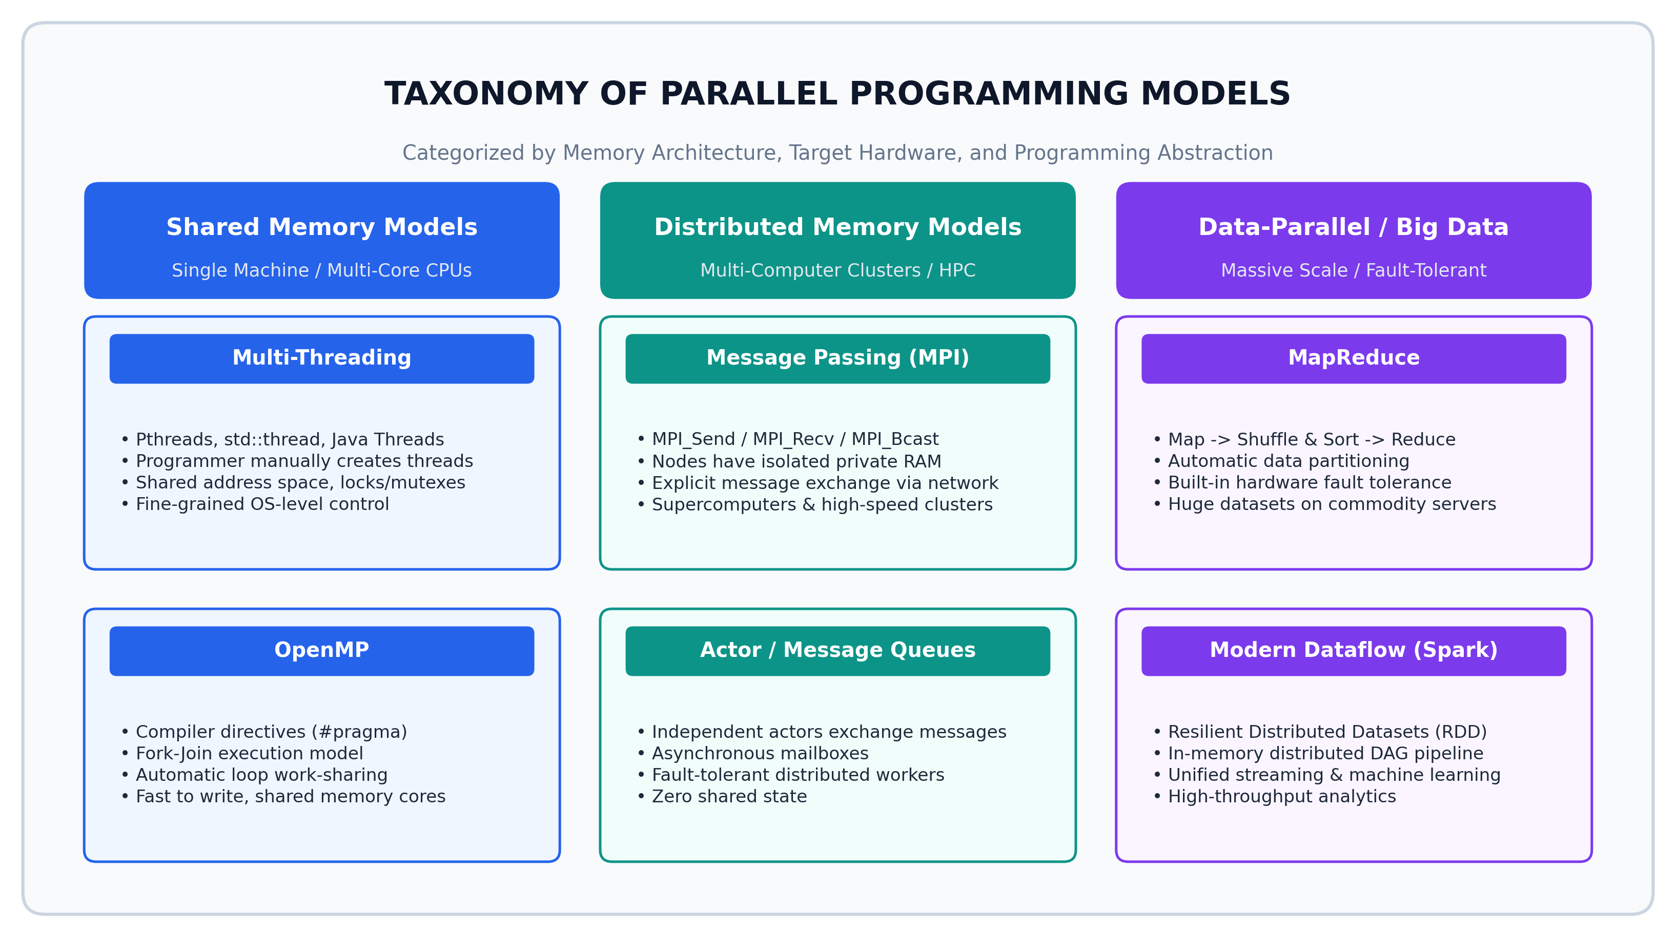
Figure 1: Taxonomy of Parallel Programming Models categorized by Memory Architecture, Target Hardware, and Abstraction Level.
🍳 Memory Anchor: The 'Four Kitchens' Analogy
To easily remember the difference between these four models during exams or interviews, picture a restaurant kitchen:
• Multi-Threading = Multiple cooks working in ONE kitchen sharing the same pantry and stove. Fast communication, but cooks bump into each other if they don't lock access to the salt shaker!
• OpenMP = A head chef with assistants standing by. The chef does prep work alone, shouts 'Everyone chop these 100 onions!' (Fork), assistants chop in parallel, and once done (Join), the head chef plates the meal.
• MPI = Four completely separate restaurants located in different cities. None can see inside each other's pantry. When Restaurant A needs cheese from Restaurant B, they must send a delivery truck with an invoice (MPI_Send) and Restaurant B must verify and sign for it (MPI_Recv).
• MapReduce = A massive bakery catering a royal banquet. 100 bakers chop apples (Map), a central conveyor belt groups all chopped apples together (Shuffle & Sort), and 5 master pastry chefs bake the final apple pies (Reduce). If one baker slips, another baker is handed a spare tray automatically!

2. Model 1: Multi-Threading Model (Thread-Based Parallelism)
The Multi-Threading Model is the foundational shared-memory programming model provided directly by operating systems and mainstream programming languages (such as C/C++, Java, C#, and Python).
In this model, a process—which represents an executing program with its own protected virtual address space—creates multiple lightweight execution units called threads. All threads belonging to the same process run concurrently across the available CPU cores while sharing the process's address space.
2.1 Architectural Setup and Memory Organization
Understanding how memory is partitioned between shared and thread-private components is essential for multithreaded programming:
- Shared Process Space: All threads share the global/static data segment, dynamically allocated Heap memory (pointers created via malloc or new), executable machine instructions (Text segment), and operating system resources such as open file descriptors, network sockets, and process credentials.
- Private Thread Context: Each thread maintains its own unique Thread ID (TID), Program Counter (PC) indicating which instruction it is executing, CPU registers storing active calculations, and an independent Call Stack storing local variables, function parameters, and return addresses.
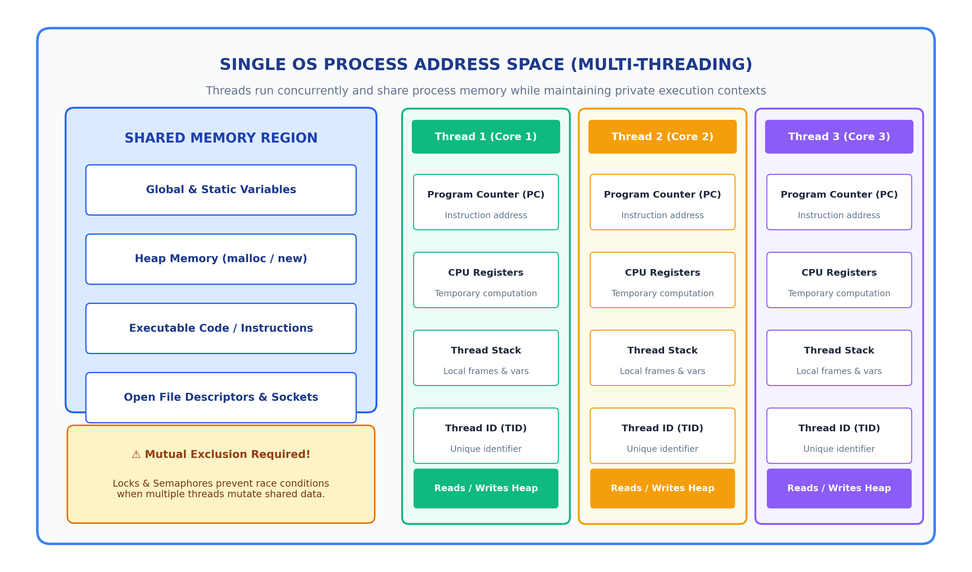
Figure 2: Architecture of a Single OS Process Address Space showing Shared Memory (Heap, Globals) vs. Private Thread Stacks and Registers.
2.2 How It Works: Thread Lifecycle and Synchronization
The operational workflow of a multithreaded application consists of four phases:
- 1. Creation & Dispatch: The main thread invokes system calls (e.g., pthread_create) to launch worker threads, passing a function pointer and task arguments.
- 2. Concurrent OS Scheduling: The operating system kernel scheduler maps the software threads onto physical hardware CPU cores. If there are 8 CPU cores and 8 threads, all 8 execute simultaneously.
- 3. Memory Coordination: Threads communicate instantaneously by writing to and reading from shared memory addresses without any network overhead.
- 4. Joining & Termination: The main thread calls pthread_join to wait for workers to finish their computations before aggregating the results.
The Synchronization Imperative: Concurrency Hazards
Because memory is shared, uncoordinated concurrent access causes critical programming bugs:
- Race Conditions: Occur when two or more threads concurrently read and write the exact same memory location, and the final outcome depends on thread timing. For example, counter++ requires three CPU instructions (read, increment, write). If two threads execute this simultaneously, one increment is lost.
- Mutex Locks: Mutual Exclusion locks ensure that only one thread can enter a critical section of code at any time. All other threads must wait until the lock is released.
- Deadlocks: A catastrophic freeze where Thread A holds Lock 1 and waits for Lock 2, while Thread B holds Lock 2 and waits for Lock 1. Neither thread can proceed.
- False Sharing: When independent variables used by different threads reside on the same 64-byte CPU cache line, causing CPU cores to constantly invalidate each other's L1 caches and degrading performance.
2.3 Concrete Code Implementation
// --- Code Implementation: C / POSIX Threads (pthreads) ---
// POSIX Threads (Pthreads) Parallel Array Sum with Mutex Protection
#include <stdio.h>
#include <stdlib.h>
#include <pthread.h>
#define NUM_THREADS 4
#define ARRAY_SIZE 1000000
int array[ARRAY_SIZE];
long long global_sum = 0;
pthread_mutex_t sum_mutex;
typedef struct {
int thread_id;
int start_idx;
int end_idx;
} TaskData;
void* compute_partial_sum(void* arg) {
TaskData* data = (TaskData*) arg;
long long local_sum = 0;
// Each thread independently sums its assigned chunk
for (int i = data->start_idx; i < data->end_idx; i++) {
local_sum += array[i];
}
// Critical Section: safely update shared global_sum
pthread_mutex_lock(&sum_mutex);
global_sum += local_sum;
pthread_mutex_unlock(&sum_mutex);
pthread_exit(NULL);
}
int main() {
pthread_t threads[NUM_THREADS];
TaskData tasks[NUM_THREADS];
pthread_mutex_init(&sum_mutex, NULL);
for (int i = 0; i < ARRAY_SIZE; i++) array[i] = 1;
int chunk = ARRAY_SIZE / NUM_THREADS;
for (int t = 0; t < NUM_THREADS; t++) {
tasks[t].thread_id = t;
tasks[t].start_idx = t * chunk;
tasks[t].end_idx = (t == NUM_THREADS - 1) ? ARRAY_SIZE : (t + 1) * chunk;
pthread_create(&threads[t], NULL, compute_partial_sum, (void*)&tasks[t]);
}
for (int t = 0; t < NUM_THREADS; t++) {
pthread_join(threads[t], NULL);
}
printf("Total Computed Sum = %lld\n", global_sum);
pthread_mutex_destroy(&sum_mutex);
return 0;
}

2.4 Advantages and Disadvantages of Multi-Threading
Dimension | Key Advantages | Critical Disadvantages
Communication | Extremely fast zero-copy communication via shared RAM pointers | Requires careful locking; high risk of race conditions and deadlocks
Hardware Fit | Perfect match for modern multi-core laptops, desktops, and servers | Cannot scale beyond a single physical computer (no network distribution)
Resource Overhead | Low creation and context-switch overhead compared to heavy OS processes | Operating system scheduling limits; context switching degrades if too many threads
Developer Burden | Native support across all major programming languages and standard libraries | Complex debugging; non-deterministic bugs that appear only under load (Heisenbugs)
Fault Tolerance | Simple crash behavior within the operating process | If one thread throws a segmentation fault, the entire process crashes immediately

2.5 Real-World Applications
- High-Performance Web Servers: Web servers such as Apache HTTP Server (Worker MPM) and Nginx use worker thread pools to handle thousands of concurrent client connections simultaneously without duplicating process memory.
- Graphical User Interfaces (GUIs): Modern desktop and mobile applications run a dedicated UI thread for animations and user input, offloading database queries, file downloads, and heavy processing to background worker threads to prevent screen freezes.
- Modern Game Engines: Game engines like Unreal Engine and Unity dedicate separate threads for physics simulations, graphics rendering, audio playback, and AI character pathfinding to maintain a steady 60+ frames per second.
⚡ Model 1 Quick Exam Recap
• Target: Single machine with multi-core CPU.
• Key Feature: All threads share the same process memory (Heap, Globals), but have private Stacks and Registers.
• Communication: Direct memory read/write (zero-copy, nanosecond speed).
• Major Danger: Race conditions, deadlocks, and false sharing. Always use Mutex locks around shared writes!

3. Model 2: Open Multi-Processing (OpenMP)
While native multithreading gives developers absolute control, writing low-level thread creation, argument struct packing, manual chunk index arithmetic, and mutex lock management is tedious, error-prone, and obscures the mathematical logic of the application.
Open Multi-Processing (OpenMP) solves this problem by providing a directive-based API for shared-memory parallel programming in C, C++, and Fortran. Instead of rewriting code from scratch, a developer takes an existing sequential algorithm and decorates loops or code blocks with compiler directives (preprocessor pragmas). The compiler then automatically generates the underlying multithreaded runtime code.
3.1 The Fork-Join Execution Paradigm
OpenMP operates strictly on the Fork-Join model of parallel execution:
- 1. Sequential Start: The program begins execution as a single thread called the Master Thread (Thread 0), running sequentially through setup code.
- 2. Fork Construct: When the master thread encounters an OpenMP parallel directive (such as #pragma omp parallel), it immediately forks a team of worker threads (Threads 1, 2, ... N-1).
- 3. Concurrent Work-Sharing: The enclosed code block or for-loop is executed concurrently by all threads in the team. OpenMP splits the loop iterations automatically across the worker threads.
- 4. Implicit Barrier & Join: At the end of the parallel block, OpenMP places an implicit barrier. All worker threads wait until the slowest thread finishes. Once synchronized, the worker threads sleep or return to the thread pool, and only the Master Thread continues executing sequentially.
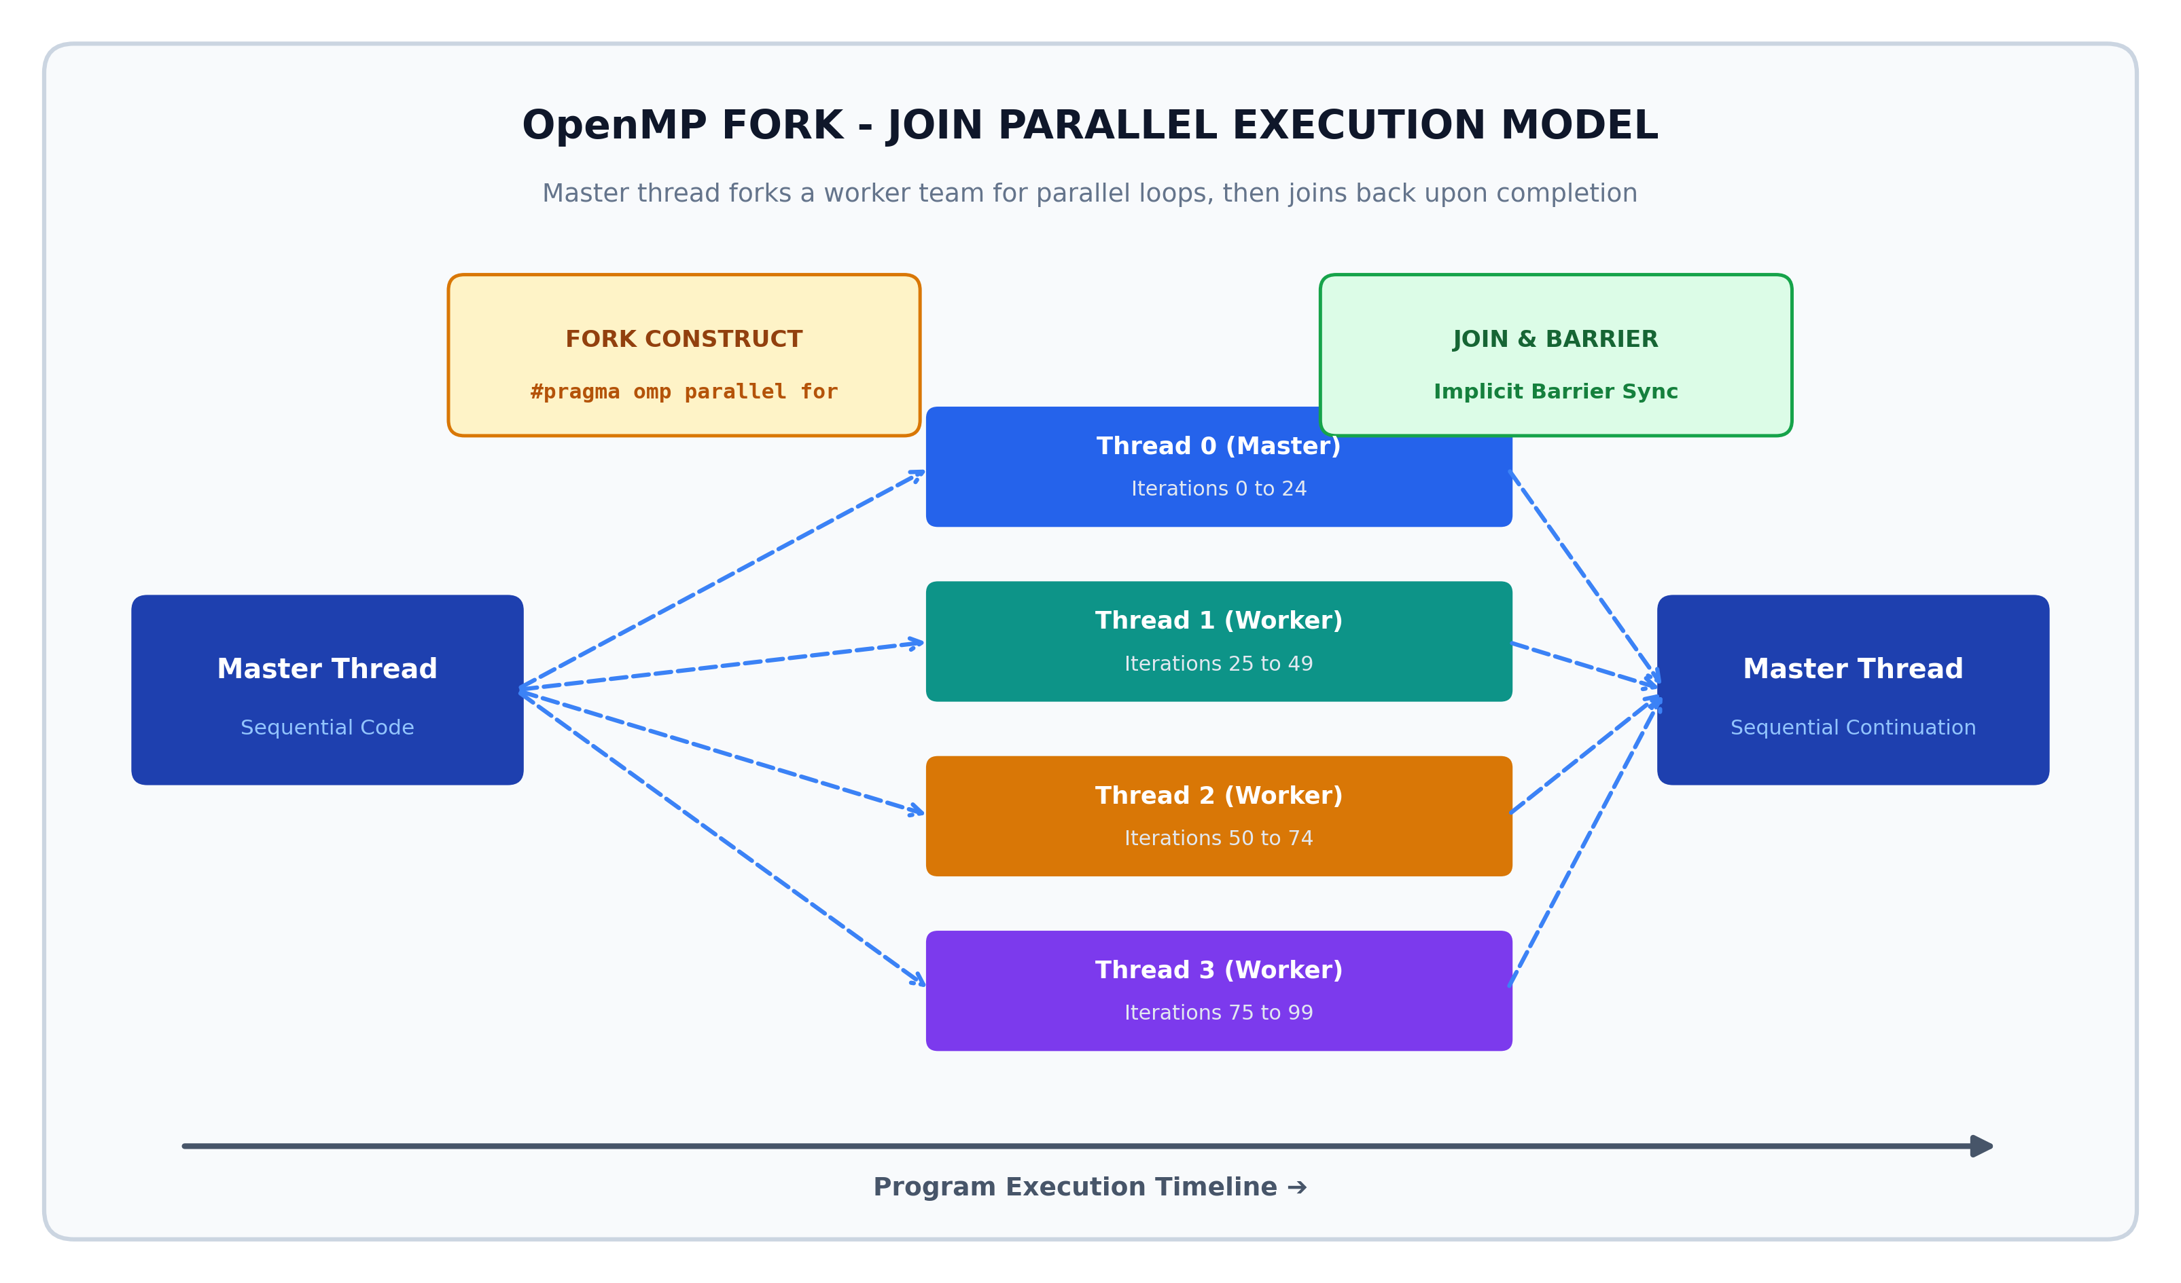
Figure 3: OpenMP Fork-Join Execution Model showing Master Thread forking into a worker team for loop chunks and joining at an implicit barrier.
3.2 Essential Directives and Scoping Clauses
OpenMP provides clear compiler directives that instruct the compiler how to parallelize execution:
- #pragma omp parallel: Creates a team of threads. Every thread executes the identical block of enclosed code.
- #pragma omp for: Work-sharing directive placed immediately above a for-loop. It automatically divides the loop iterations among the threads in the active team.
- #pragma omp parallel for: A combined shortcut that both forks the thread team and distributes loop iterations in a single line of code.
- shared(var): Declares that a variable is shared among all threads. There is only one copy in memory.
- private(var): Creates an uninitialized local copy of the variable for each thread on its private stack. Changes made by one thread are completely invisible to others.
- reduction(operator : variable): An essential clause for computing sums, products, minimums, or maximums across loop iterations. OpenMP gives each thread a private accumulator initialized to 0. Each thread sums its own loop chunk locally with ZERO mutex overhead. When all threads reach the join barrier, OpenMP atomically combines all local accumulators into the final global variable. This completely prevents race conditions while delivering maximum speedup!
- schedule(type, chunk): Controls loop distribution. 'static' divides iterations into equal fixed chunks before execution begins (ideal for predictable work). 'dynamic' gives chunks to threads on demand as they finish previous chunks (ideal for loops where some iterations take much longer than others).
3.3 Concrete Code Implementation
// --- Code Implementation: C / OpenMP (#pragma directives) ---
// OpenMP Parallel Array Summation with Automatic Reduction
#include <stdio.h>
#include <stdlib.h>
#include <omp.h>
#define ARRAY_SIZE 1000000
int main() {
int* array = (int*) malloc(ARRAY_SIZE * sizeof(int));
long long total_sum = 0;
for (int i = 0; i < ARRAY_SIZE; i++) array[i] = 1;
double start_time = omp_get_wtime();
// Single directive forks threads, splits loop iterations,
// and eliminates race conditions via private thread reduction accumulators
#pragma omp parallel for reduction(+: total_sum) schedule(static)
for (int i = 0; i < ARRAY_SIZE; i++) {
total_sum += array[i];
}
double end_time = omp_get_wtime();
printf("Total Sum Computed = %lld\n", total_sum);
printf("Execution Time = %f seconds\n", end_time - start_time);
printf("Threads Utilized = %d\n", omp_get_max_threads());
free(array);
return 0;
}

3.4 Advantages and Disadvantages of OpenMP
Dimension | Key Advantages | Critical Disadvantages
Ease of Adoption | Incremental parallelization; sequential code remains intact and runs if OpenMP flag is disabled | Only supports shared-memory systems; cannot scale across network clusters
Code Simplicity | Eliminates low-level boilerplate thread creation and manual index chunk arithmetic | Less fine-grained control over individual thread lifecycles, affinity, or async I/O
Performance | Highly optimized compiler runtime with automated thread reuse and minimal overhead | Requires careful variable scoping; accidentally sharing an index variable causes silent bugs
Portability | Standardized across GCC, Clang, Intel ICC, and MSVC compilers on Linux, Windows, macOS | Complex recursive tasks and irregular graph traversals can be difficult to express cleanly
Safety | Reduction clause eliminates lock contention overhead and prevents common race conditions | Debugging multithreaded data races requires specialized tools (Intel Inspector, Valgrind)

3.5 Real-World Applications
- Scientific Simulations: Physics and engineering engines use OpenMP to parallelize massive matrix transformations, finite element analyses, and fluid dynamics simulations on multi-core workstations.
- Linear Algebra Libraries: High-performance linear algebra packages such as BLAS, LAPACK, and Intel oneMKL rely on OpenMP pragmas to speed up matrix multiplication and eigenvalues computation across all available CPU cores.
- Medical Image Processing: MRI, CT scan reconstruction, and digital video filter applications process multi-gigabyte pixel arrays in parallel chunks using OpenMP loop directives.
🚀 Model 2 Quick Exam Recap
• Target: Multi-core CPUs (Shared Memory Systems).
• Key Feature: The programmer adds simple #pragma compiler directives to parallelize existing loops without rewriting algorithms.
• Core Paradigm: Fork-Join Model (Master thread forks worker team, distributes loop iterations, joins at barrier).
• Essential Keyword: reduction(+: sum) eliminates race conditions by maintaining private accumulators per thread without mutex locking!

4. Model 3: Message Passing Interface (MPI)
Both native multi-threading and OpenMP share an unavoidable physical limit: they only work on a single physical computer sharing one set of RAM modules. Once a computational problem is too large to fit in a single workstation's memory—such as global weather forecasting, nuclear simulation, or training trillion-parameter AI models—we must connect hundreds or thousands of independent computers together into a cluster.
In a cluster, computers do not share memory. A processor on Node 1 cannot directly read or write RAM on Node 2. To solve this, the Message Passing Interface (MPI) was standardized. MPI is the undisputed foundation of distributed-memory High-Performance Computing (HPC) and supercomputing worldwide.
4.1 Architectural Setup and Distributed Memory Model
The MPI architecture differs fundamentally from shared-memory models:
- Isolated Address Spaces: Every participating process runs in its own private memory space. A pointer address 0x7FFF1234 on Node 0 has no meaning on Node 1.
- High-Speed Interconnect: Processes communicate strictly by sending explicit packets across physical network interfaces (such as Gigabit Ethernet or ultra-low latency InfiniBand switches).
- No Shared State: Because memory is not shared, race conditions on memory variables are physically impossible. However, developers must explicitly decide when, what, and to whom data is transmitted.
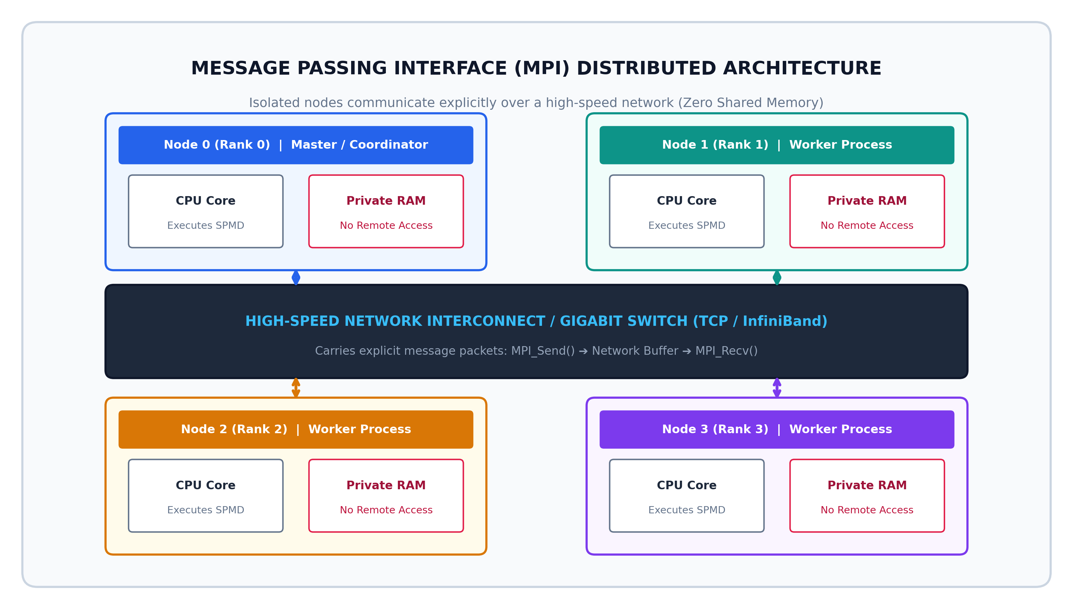
Figure 4: MPI Distributed Memory Architecture showing independent physical nodes with private RAM communicating over a high-speed network interconnect.
4.2 How MPI Works: The SPMD Paradigm and Communicators
MPI operates on the Single Program, Multiple Data (SPMD) model. The developer writes one single program executable, and the MPI runtime (mpirun or mpiexec) launches identical copies of that binary simultaneously across all nodes in the cluster.
- Communicator: A group of communicating processes. The default communicator is MPI_COMM_WORLD, which encompasses every process started by the job runner.
- Rank: Each process is assigned a unique integer ID called its Rank, ranging from 0 to Size - 1. Rank 0 is conventionally designated as the Master / Coordinator node, while Ranks 1 to N-1 serve as Worker nodes. In code, an if (rank == 0) block handles coordination, while else blocks execute worker logic.
- Point-to-Point Communication: One sender process transmits data directly to one receiver process using MPI_Send and MPI_Recv. Both processes must agree on the buffer address, data count, MPI datatype (e.g., MPI_INT, MPI_DOUBLE), destination/source rank, and a message tag.
- Collective Communication: Coordinated operations involving all processes in a communicator:
• MPI_Bcast: Transmits data from the root node to all other processes.
• MPI_Scatter: Takes an array on the root node and slices it into equal pieces, giving one piece to each process.
• MPI_Gather: Collects partial array pieces from all processes and stitches them back together on the root node.
• MPI_Reduce: Collects values from all processes, applies an associative mathematical operation (such as MPI_SUM or MPI_MAX), and delivers the final answer to the root node.
4.3 Concrete Code Implementation
// --- Code Implementation: C / MPI (Message Passing Interface) ---
// MPI Distributed Array Summation using MPI_Reduce
#include <stdio.h>
#include <stdlib.h>
#include <mpi.h>
#define TOTAL_ELEMENTS 1000000
int main(int argc, char** argv) {
int rank, size;
long long local_sum = 0;
long long total_sum = 0;
MPI_Init(&argc, &argv); // Initialize MPI environment
MPI_Comm_rank(MPI_COMM_WORLD, &rank); // Get process unique ID
MPI_Comm_size(MPI_COMM_WORLD, &size); // Get total number of nodes
int chunk = TOTAL_ELEMENTS / size;
int start = rank * chunk;
int end = (rank == size - 1) ? TOTAL_ELEMENTS : (rank + 1) * chunk;
// Each node calculates the sum of its assigned sub-range in private RAM
for (int i = start; i < end; i++) {
local_sum += 1; // Simulated workload
}
// Collective Communication: Reduce all partial sums to Rank 0 using MPI_SUM
MPI_Reduce(&local_sum, &total_sum, 1, MPI_LONG_LONG, MPI_SUM, 0, MPI_COMM_WORLD);
// Only the Master node outputs the grand total
if (rank == 0) {
printf("Cluster Nodes Participating = %d\n", size);
printf("Grand Total Computed Sum = %lld\n", total_sum);
}
MPI_Finalize(); // Clean up MPI environment
return 0;
}

4.4 Advantages and Disadvantages of MPI
Dimension | Key Advantages | Critical Disadvantages
Scalability | Virtually unlimited scalability; runs on thousands of computers and millions of cores | Network latency is thousands of times slower than reading local RAM cache
Memory Model | No shared memory means zero race conditions on memory variables | Programmer must manually partition all data structures and manage network buffers
Portability | Universal open standard; supported on virtually every supercomputer and cluster operating system | Communication deadlocks occur easily if Send and Recv calls mismatch in order or tags
Hardware Support | Leverages specialized low-latency hardware (InfiniBand RDMA, Cray Aries interconnects) | Requires specialized cluster setup (mpirun daemon, SSH keys, network switches)
Fault Tolerance | High performance under standard operating conditions | Traditional MPI lacks fault tolerance; if one node crashes, the entire job typically aborts

4.5 Real-World Applications
- Global Climate & Weather Modeling: Meteorological systems such as ECMWF and NOAA divide the Earth's atmosphere into 3D geographic grids. Each supercomputing node computes air pressure, temperature, and moisture for its sector and exchanges boundary data with neighboring nodes via MPI.
- TOP500 Supercomputers: All of the world's top supercomputers (e.g., Frontier at Oak Ridge National Lab, Fugaku in Japan, Summit) run MPI as their core communications backbone for scientific research.
- Aerospace & Automotive Aerodynamics: Aircraft manufacturers simulate air turbulence over airplane wings by running computational fluid dynamics (CFD) solvers across multi-thousand-node MPI clusters.
🌐 Model 3 Quick Exam Recap
• Target: Clusters of independent computers (Distributed Systems).
• Key Feature: Each process has its own isolated private memory and communicates strictly via explicit messages.
• Core Execution: SPMD (Single Program, Multiple Data) identified by process 'Rank'.
• Primitives to Remember: Point-to-Point (MPI_Send, MPI_Recv) and Collective (MPI_Bcast, MPI_Scatter, MPI_Gather, MPI_Reduce).

5. Model 4: MapReduce Programming Model
While MPI is magnificent for tightly-coupled, math-heavy scientific simulations where every microsecond of network latency counts, it is exceptionally difficult and brittle for massive Big Data analytics. In big data, datasets span terabytes or petabytes across thousands of cheap, unreliable commodity servers where hard drives fail daily.
To solve this, Jeffrey Dean and Sanjay Ghemawat at Google pioneered the MapReduce programming model in 2004 (subsequently open-sourced via the Apache Hadoop ecosystem). MapReduce is designed around a radical philosophy: 'Move computation to where the data lives (Data Locality), rather than moving petabytes of data across the network to compute nodes.'
5.1 The Three-Phase Pipeline Explained
MapReduce abstracts away all network sockets, threading, and disk operations, requiring the programmer to define only two functions: Map and Reduce. The framework executes in three distinct phases:
- 1. Map Phase: The input dataset (stored in a distributed filesystem such as HDFS or Google GFS) is split into independent 64MB or 128MB chunks. A Mapper task runs on the exact physical server where that chunk is stored. The Mapper parses records and emits intermediate key-value pairs: Map(k1, v1) ➔ list(k2, v2).
- 2. Shuffle & Sort Phase (The Magic of MapReduce): This automatic framework stage operates between Map and Reduce. The system hashes and partitions the intermediate keys, transmits pairs across the network, and sorts them so that all values associated with the same key arrive at the exact same Reducer worker: (k2, list(v2)).
- 3. Reduce Phase: A Reducer worker receives a unique key and the complete list of all intermediate values generated for that key across the entire cluster. It aggregates, filters, or combines the values and writes the final condensed results to distributed storage: Reduce(k2, list(v2)) ➔ list(k3, v3).
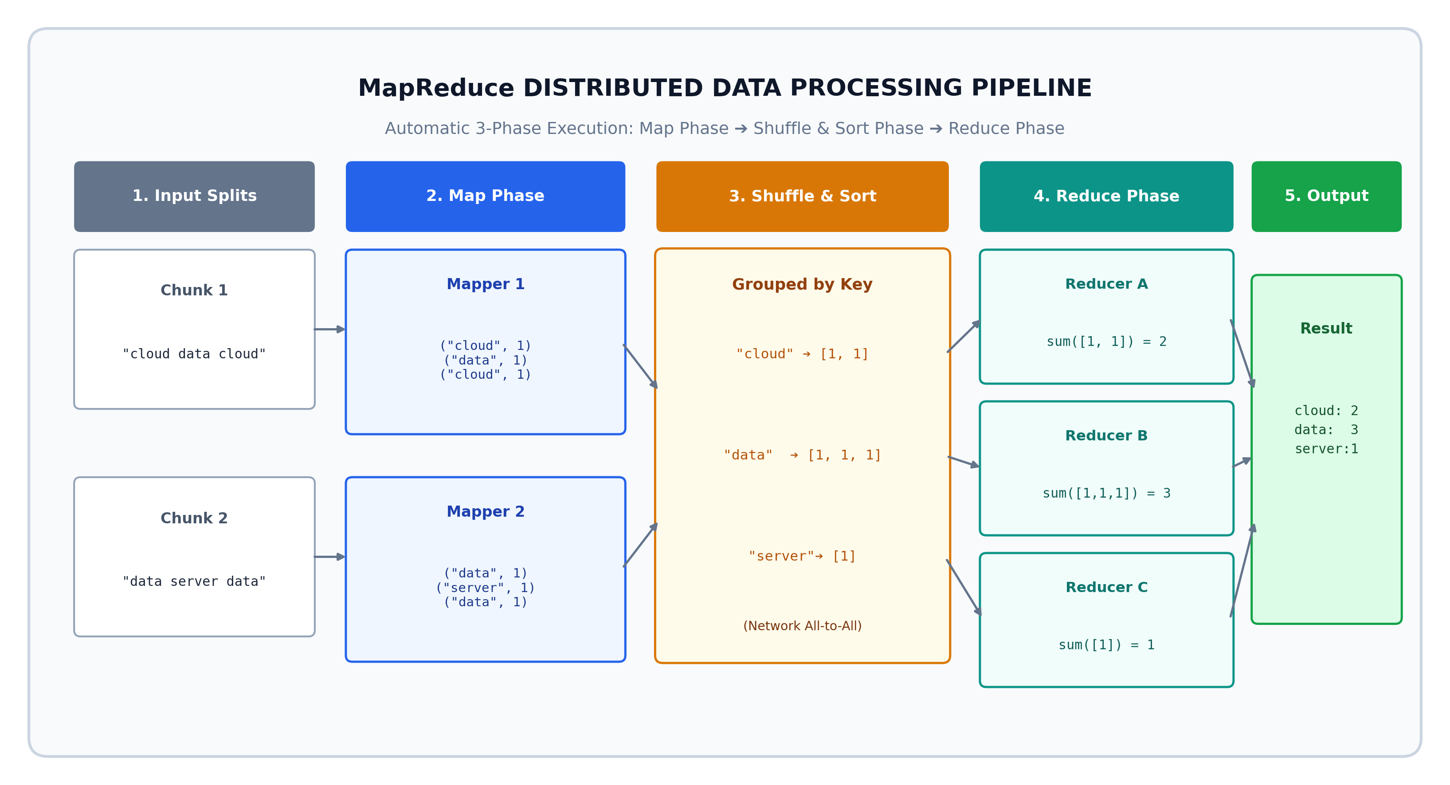
Figure 5: MapReduce Execution Pipeline showing Input Splits, Map Phase, Shuffle & Sort key-grouping, Reduce Phase, and Final Output aggregation.
5.2 Detailed Walkthrough: The Classic Word Count Example
To see MapReduce in action, consider counting the frequency of every word across millions of web pages:
- Step 1 (Input Chunking): Node 1 receives Chunk 1: 'cloud data cloud'. Node 2 receives Chunk 2: 'data server data'.
- Step 2 (Map Execution): Mapper 1 reads its text and emits:
('cloud', 1), ('data', 1), ('cloud', 1)
Mapper 2 reads its text and emits:
('data', 1), ('server', 1), ('data', 1)
- Step 3 (Shuffle & Sort): The MapReduce framework groups pairs by key across the network:
'cloud' ➔ [1, 1]
'data' ➔ [1, 1, 1]
'server' ➔ [1]
- Step 4 (Reduce Aggregation): Reducer A sums the list for 'cloud': 1 + 1 = 2 ➔ ('cloud', 2)
Reducer B sums the list for 'data': 1 + 1 + 1 = 3 ➔ ('data', 3)
Reducer C sums the list for 'server': 1 = 1 ➔ ('server', 1)
- Step 5 (Final Output): The aggregated counts are written safely back to distributed storage.
5.3 Concrete Code Implementation
// --- Code Implementation: Python / Hadoop MapReduce Streaming ---
# MapReduce Implementation (Python Streaming / Hadoop Paradigm)
import sys
# ==================== MAPPER (mapper.py) ====================
def mapper():
# Reads lines from standard input (HDFS data chunks)
for line in sys.stdin:
words = line.strip().split()
for word in words:
# Emits intermediate key-value pair separated by tab
print(f"{word.lower()}\t1")
# ==================== REDUCER (reducer.py) ====================
def reducer():
current_word = None
current_count = 0
# Standard input arrives pre-sorted by key thanks to Shuffle & Sort
for line in sys.stdin:
word, count = line.strip().split('\t')
count = int(count)
if current_word == word:
current_count += count
else:
if current_word:
# Output final aggregated word count
print(f"{current_word}\t{current_count}")
current_word = word
current_count = count
if current_word:
print(f"{current_word}\t{current_count}")
# Framework execution: cat input.txt | python mapper.py | sort | python reducer.py

5.4 Built-In Superpowers: Fault Tolerance and Scalability
MapReduce possesses architectural capabilities that make it unique among parallel models:
- Automatic Hardware Fault Tolerance: In a cluster of 5,000 servers, hardware crashes are daily certainties. A Master node continuously monitors worker health via heartbeat pings. If a worker fails to respond, the master marks its task as failed and re-assigns that specific chunk's task to another server holding an HDFS replica. The programmer's code never has to handle node crashes!
- Transparent Data Locality: The master scheduler places compute tasks on the specific physical machine that already has the required data block on its local hard drive, eliminating unnecessary network bandwidth usage.
- Linear Horizontal Scalability: If a job on 50 nodes takes 10 hours, adding 50 more nodes cuts the execution time in half with zero modifications to the application code.
5.5 Advantages and Disadvantages of MapReduce
Dimension | Key Advantages | Critical Disadvantages
Fault Tolerance | Built-in automated node failure recovery without restarting the overall job | High disk I/O latency; intermediate state is written to disk between phases
Ease of Programming | Hides all network protocols, socket communication, threading, and data partitioning | Rigid programming model; algorithms must be contorted into Map and Reduce stages
Scalability | Easily scales to petabytes of data across thousands of cheap commodity computers | Poor fit for iterative algorithms (e.g., machine learning loops, graph traversal)
Data Locality | Computes tasks directly on nodes holding the data blocks, minimizing network bottlenecks | High latency startup overhead; unsuitable for real-time interactive queries
Commodity Hardware | Runs on standard, inexpensive consumer-grade hardware without costly InfiniBand switches | Replaced in modern real-time streaming by in-memory engines like Apache Spark

5.6 Real-World Applications
- Google Search Web Indexing: Google originally processed the entire crawled World Wide Web using MapReduce pipelines to parse HTML documents, extract links, compute PageRank, and generate the reverse inverted search index.
- Big Data Log Analysis: E-commerce giants like Amazon and Netflix process billions of server clickstream logs daily using MapReduce/Hadoop jobs to detect fraud and compute analytics.
- Enterprise ETL Pipelines: Banks and telecommunications companies run nightly MapReduce batch jobs to clean, transform, and aggregate terabytes of transactional data into data warehouses.
📊 Model 4 Quick Exam Recap
• Target: Distributed data processing on massive Big Data clusters.
• Key Feature: Splits tasks into Map and Reduce phases for parallel execution.
• Three Phases: 1. Map (generates key-value pairs) ➔ 2. Shuffle & Sort (groups data by key across network) ➔ 3. Reduce (aggregates values per key).
• Ultimate Superpower: Automatic hardware fault tolerance and data locality (runs where data sits).

6. Comprehensive Comparison and Selection Guide
Each of the four parallel programming models is engineered for distinct hardware architectures, dataset dimensions, and developer constraints. To summarize their core differences, Table 4 provides a 10-point head-to-head comparison matrix.
Comparison Dimension | Multi-Threading | OpenMP | Message Passing (MPI) | MapReduce
Target Hardware | Multi-core CPUs (Single machine) | Multi-core CPUs (Single machine) | Distributed cluster nodes / Supercomputers | Massive clusters of commodity servers
Memory Architecture | Shared Memory (One address space) | Shared Memory (One address space) | Distributed Memory (Private RAM per node) | Distributed Storage (HDFS / GFS)
Programming Paradigm | Thread lifecycle & explicit locks | Compiler directives (#pragma) | SPMD (Single Program Multiple Data) | Data-Parallel Functional (Map & Reduce)
Communication Mechanism | Instant read/write to shared RAM | Shared memory via work-sharing loops | Explicit network packets (MPI_Send/Recv) | Automatic Shuffle & Sort network transfer
Developer Complexity | High (Manual locks, thread joins) | Low to Medium (Pragmas over loops) | High (Manual data slicing & network tags) | Low to Medium (Define Mapper & Reducer)
Synchronization | Mutexes, Semaphores, Barriers | Implicit join barriers, Reduction clause | Point-to-point handshake, MPI_Barrier | Implicit barrier between Map and Reduce
Fault Tolerance | None (Thread fault crashes process) | None (Core fault crashes process) | Low (Node crash halts traditional job) | High (Automatic task restart on healthy nodes)
Primary Performance Goal | Concurrency & Low Latency | Raw Compute Speed on Loops | Massive Numerical HPC Throughput | High-Throughput Batch Big Data
Typical Data Scale | Gigabytes (Fits in single machine RAM) | Gigabytes (Fits in workstation RAM) | Terabytes of simulation grid state | Terabytes to Petabytes of unstructured data
Primary Industry Domain | Web servers, GUIs, Game engines | Physics engines, Image filters, Math | Climate models, Molecular dynamics, CFD | Web indexing, Log analytics, ETL batch

6.1 Practical Decision Guide
When embarking on a new software engineering project, choosing the wrong parallel model results in wasted engineering effort or severe performance bottlenecks. Figure 6 provides a practical decision tree to guide model selection based on infrastructure, dataset scale, and developer requirements.
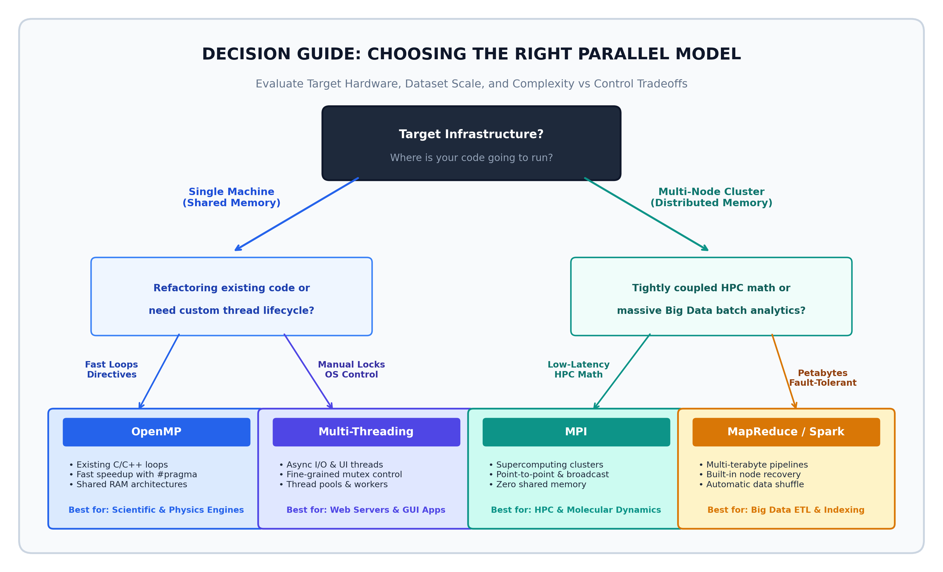
Figure 6: Decision Flowchart for selecting the optimal parallel programming model based on hardware infrastructure, dataset scale, and control constraints.
6.2 Hybrid Parallelism: Combining MPI and OpenMP
In modern high-performance computing, systems are rarely pure shared-memory or pure distributed-memory. Instead, modern supercomputers consist of thousands of cluster nodes, where each node houses dual 64-core processors sharing local RAM.
To maximize efficiency on such architectures, engineers use Hybrid Parallelism (often called 'MPI + X'):
- Inter-Node Communication (MPI): MPI handles communication between distinct physical servers over the network switch.
- Intra-Node Parallelism (OpenMP): Inside each server, OpenMP manages loop parallelism across the 128 local CPU cores, eliminating unnecessary MPI message serialization over the local PCIe bus and dramatically reducing memory footprints.
6.3 Modern Evolution: Apache Spark and GPU Acceleration
The parallel programming landscape continues to evolve rapidly:
- Apache Spark: Evolved from MapReduce to solve the high disk I/O bottleneck. Spark keeps intermediate data in RAM across the cluster using Resilient Distributed Datasets (RDDs), running iterative algorithms up to 100 times faster than Hadoop MapReduce.
- GPU Acceleration (CUDA / OpenACC): Modern deep learning and scientific visualization offload data-parallel computations to graphics processors containing thousands of small stream cores running massively parallel matrix multiplications.
7. Conclusion
Parallel computing is no longer a niche domain reserved for government supercomputers; it is an absolute requirement for every modern software engineer. As sequential processor speeds remain bounded by physical power constraints, software performance is dictated entirely by how effectively applications exploit concurrent processing units.
Through this comprehensive assignment, we examined the four fundamental parallel programming paradigms covered in our curriculum:
- 1. Multi-Threading provides fine-grained, low-overhead OS concurrency inside a single process, making it indispensable for interactive desktop apps, games, and web servers, though requiring vigilant protection against race conditions.
- 2. OpenMP democratizes shared-memory parallel computing by allowing engineers to accelerate existing numerical C/C++ loops using elegant compiler pragmas, work-sharing directives, and race-free reduction clauses.
- 3. MPI powers global supercomputing clusters through explicit message passing across distributed-memory machines, achieving unparalleled mathematical throughput at the cost of manual network coordination.
- 4. MapReduce revolutionized big data engineering by coupling functional data transformations with automatic cluster fault tolerance and data locality, processing petabytes across commodity servers without exposing low-level network complexity.
Mastering these four models equips a software engineer with the versatility to design systems that scale seamlessly from a single multi-core smartphone up to multi-thousand-node supercomputing clusters and global cloud pipelines.
8. References & Academic Bibliography
Dean, J., & Ghemawat, S. (2004). MapReduce: Simplified Data Processing on Large Clusters. In Proceedings of the 6th Symposium on Operating System Design and Implementation (OSDI'04), pp. 137–150.
Pacheco, P. S. (2011). An Introduction to Parallel Programming. Morgan Kaufmann / Elsevier.
Tanenbaum, A. S., & van Steen, M. (2017). Distributed Systems: Principles and Paradigms (3rd ed.). CreateSpace Independent Publishing.
OpenMP Architecture Review Board. (2021). OpenMP Application Programming Interface Specification, Version 5.2. OpenMP.org.
Message Passing Interface Forum. (2021). MPI: A Message-Passing Interface Standard, Version 4.0. High-Performance Computing Center Stuttgart.
Coulouris, G., Dollimore, J., Kindberg, T., & Blair, G. (2011). Distributed Systems: Concepts and Design (5th ed.). Addison-Wesley.
Grama, A., Gupta, A., Karypis, G., & Kumar, V. (2003). Introduction to Parallel Computing (2nd ed.). Pearson Education.

